**ALM Notes**

**Sites**

<http://alm3/qcbin>

**Reference**

System Testing/Enterprise Release 14.3/PP Avanteos Term Deposits

.

JCL: SDAF.PPAVENT.CNTL.TEST.DESIGNER(CF180D9A)

Input file: SDAF.CF.CF180.DD761.GODXDATA

Output file: SDAF.CF.CF180D9A.ACCTS.PRIMARY.CUST

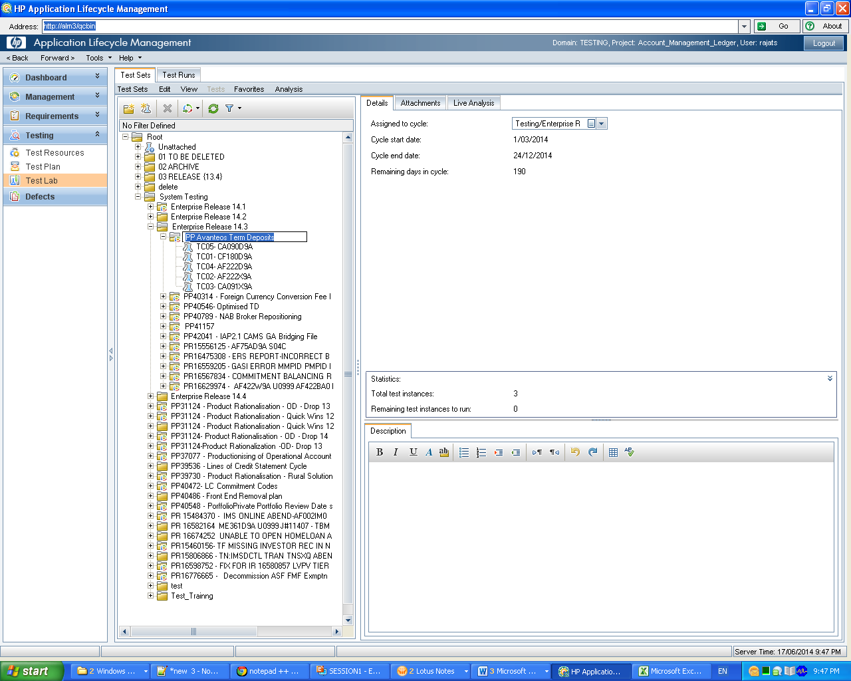**Logging into ALM**

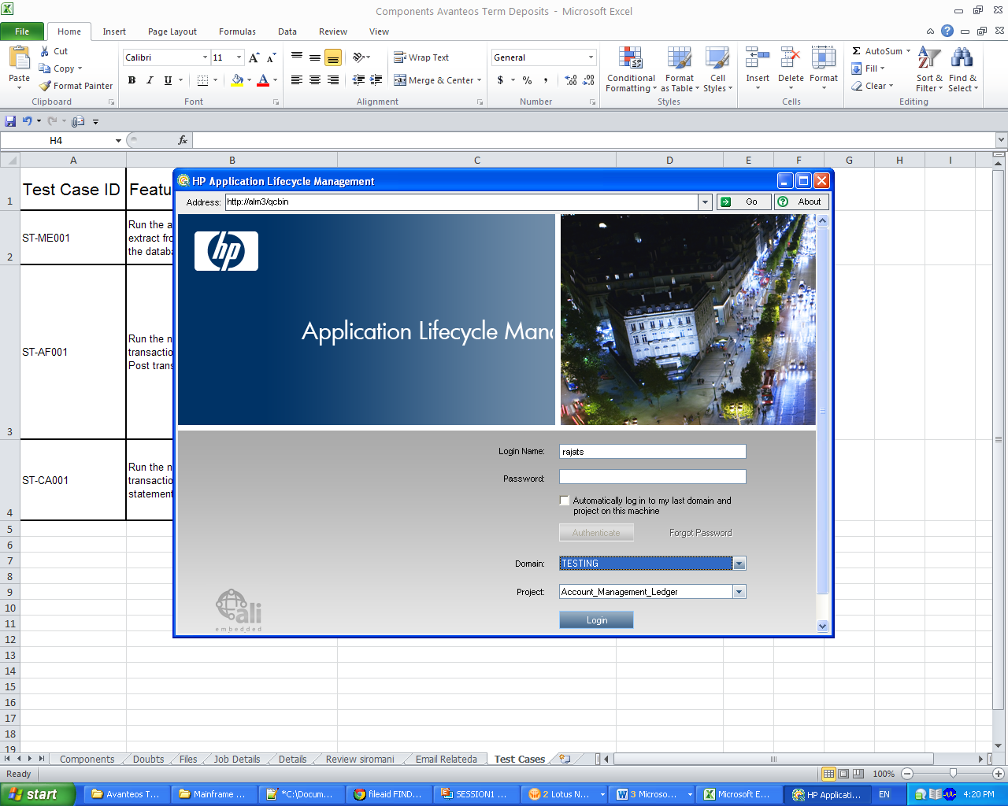

**Creation of Test Cases in ALM**

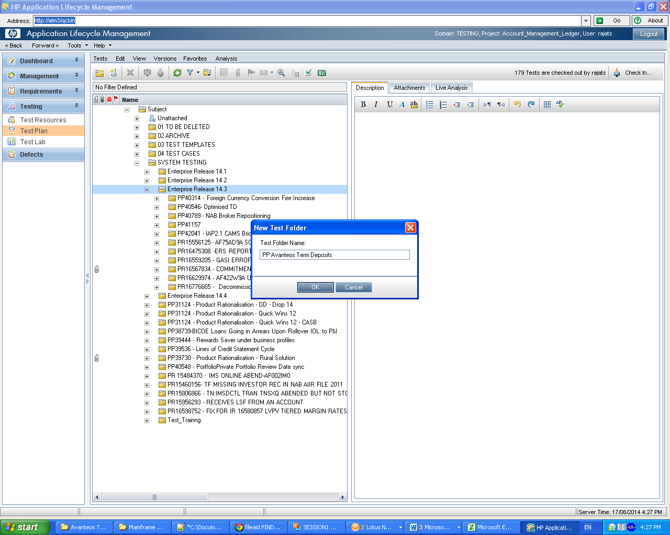

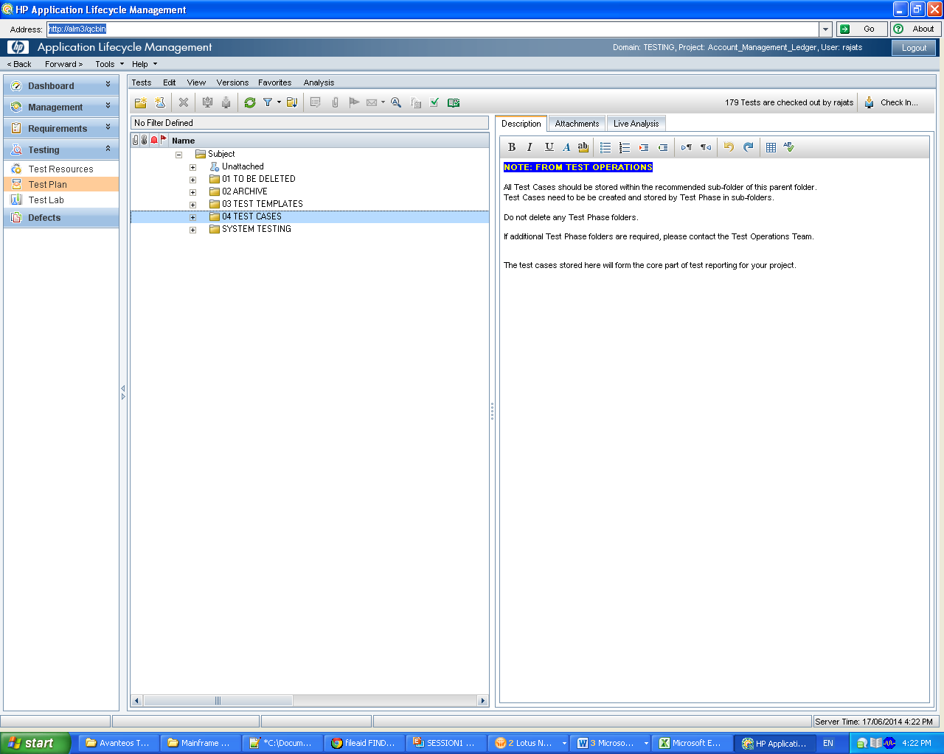

**Project**: Bank Enterprise Release 14.3_48465 (Please note that this is 14.3 release)

System Impact: CAMS - Product Rules_BA1095

Test Stream : Testing Services

Type of Test : Functional

Batch Group : online

After entering above details press Ok.

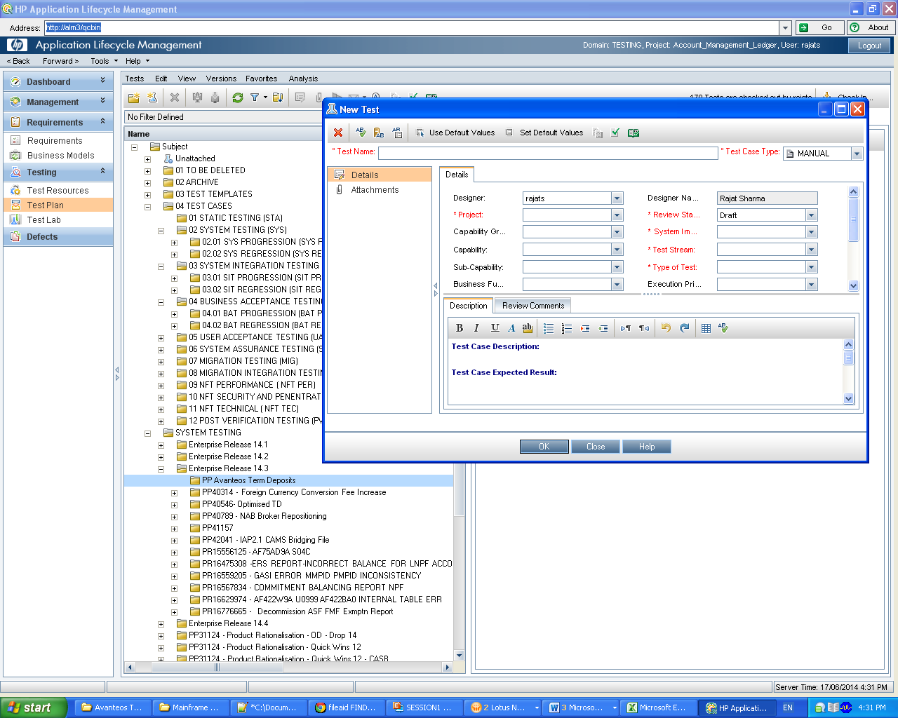

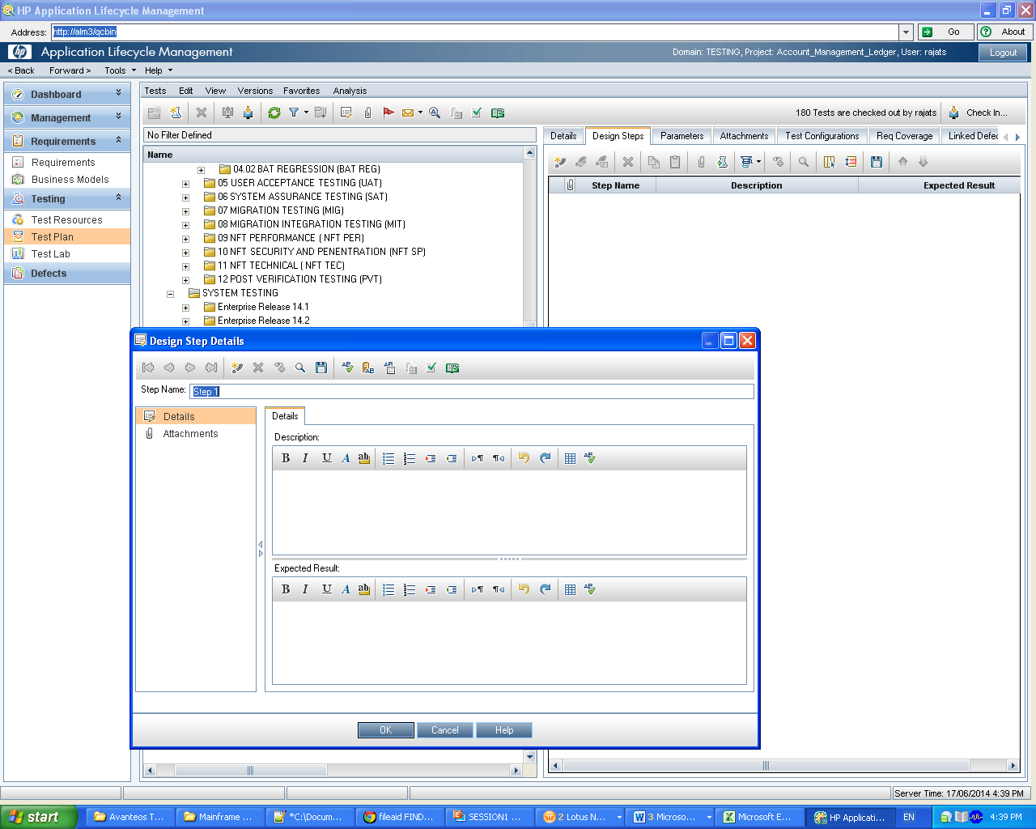

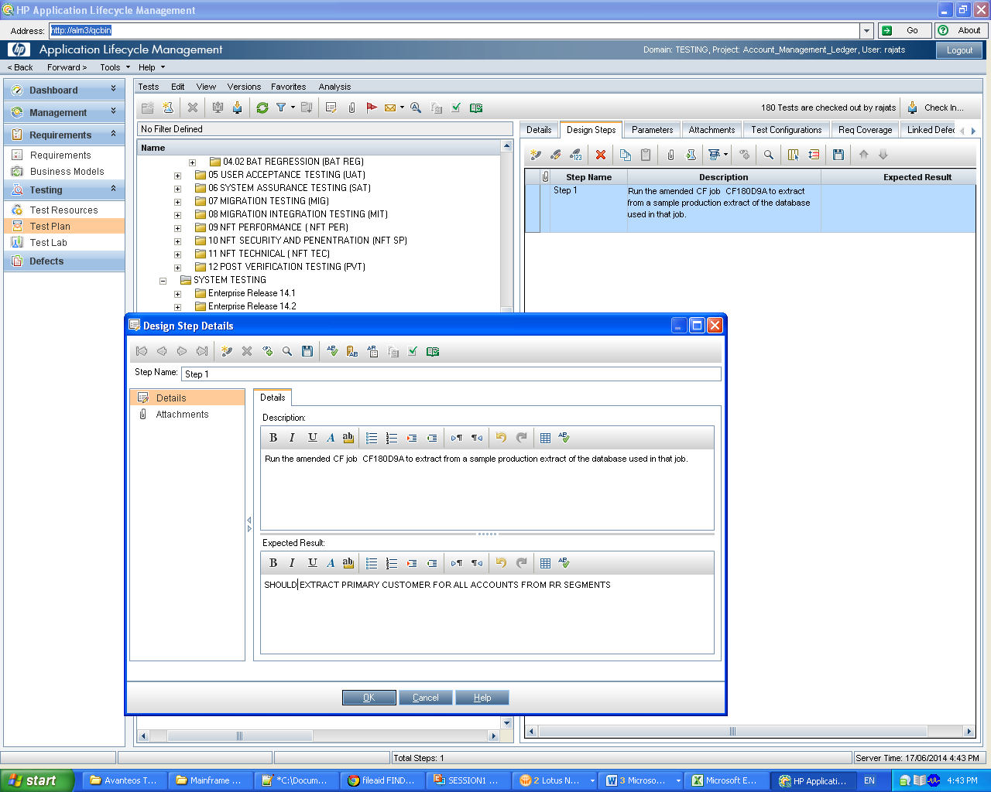

**Go to TEST LAB**

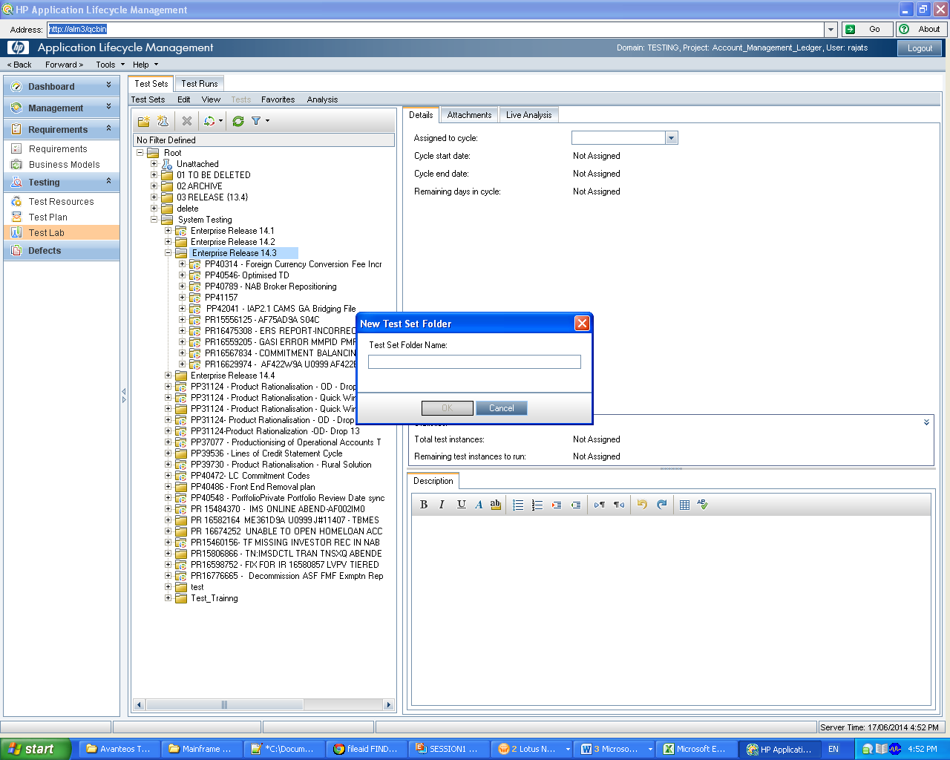

**Test Phase :** Test - System Testing

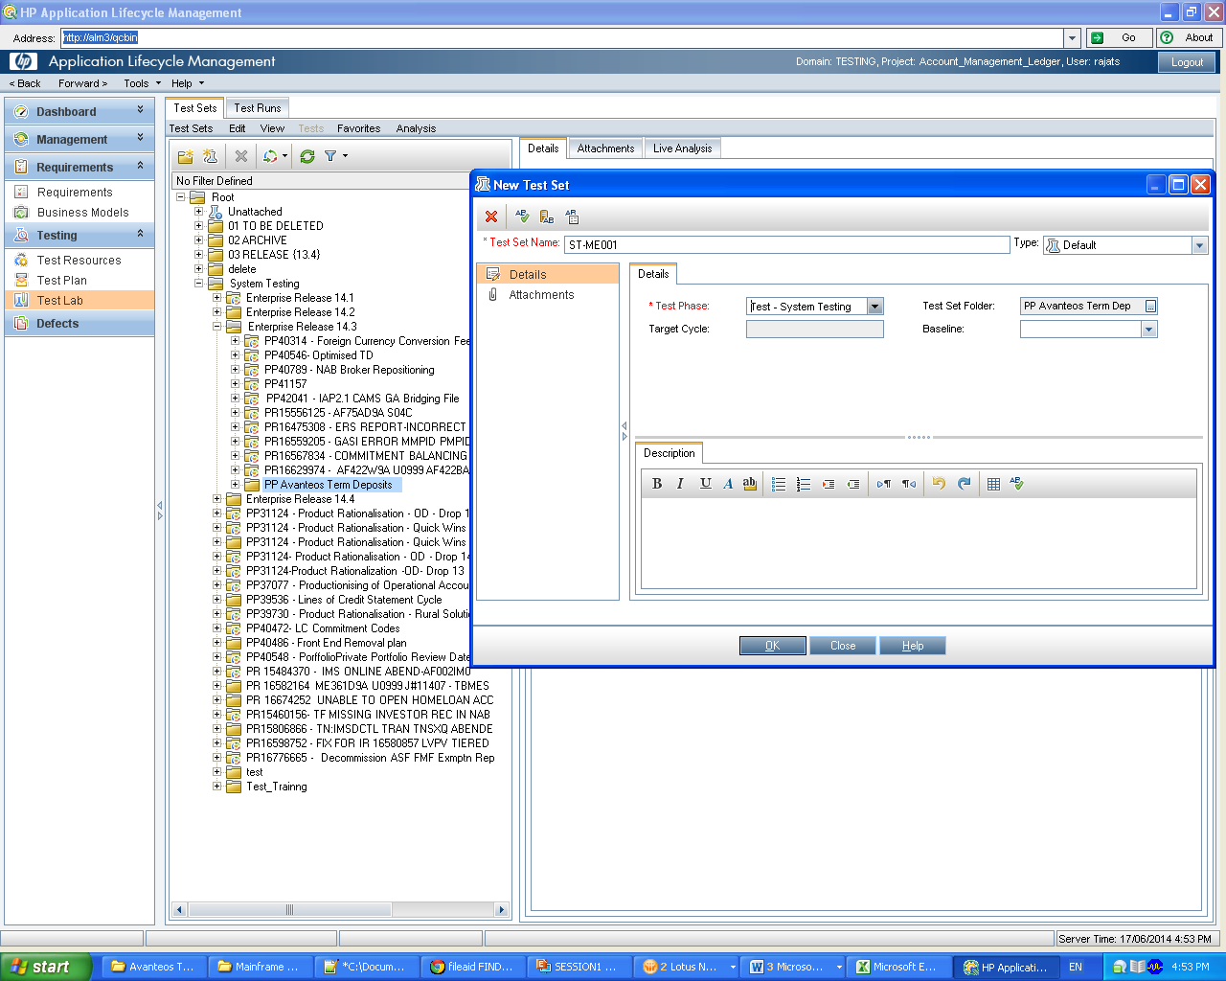

Mapping Test lab testcases with test plan test cases

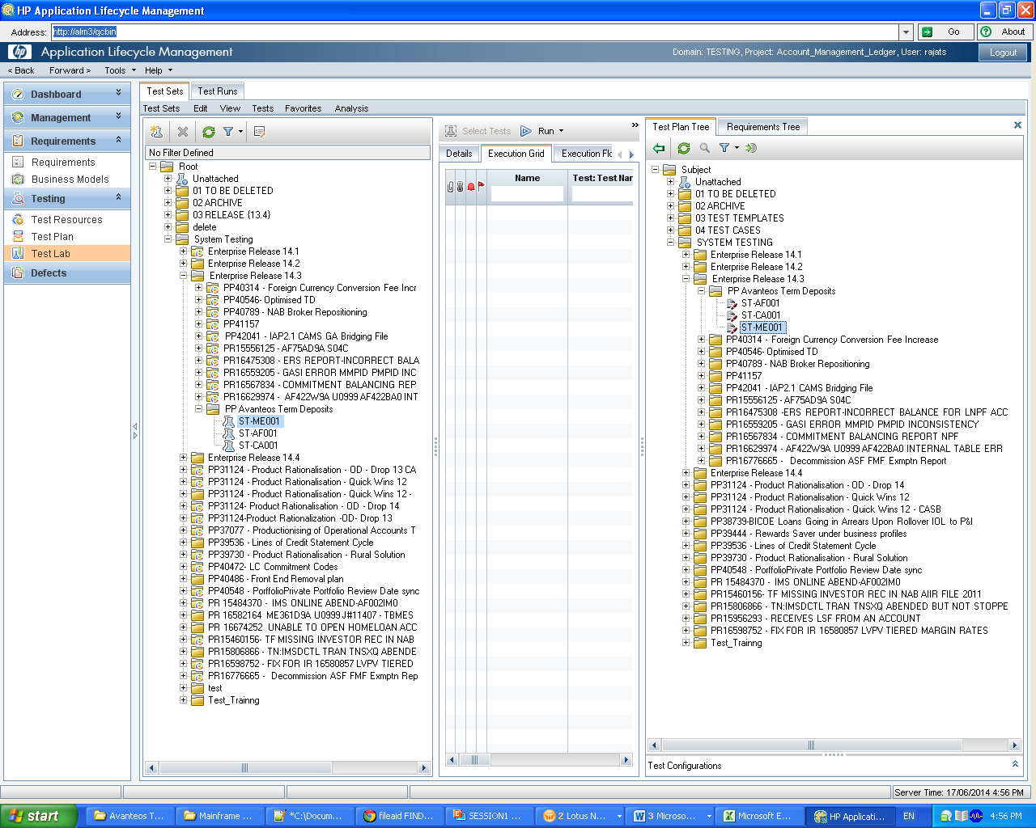

Assign to cycle

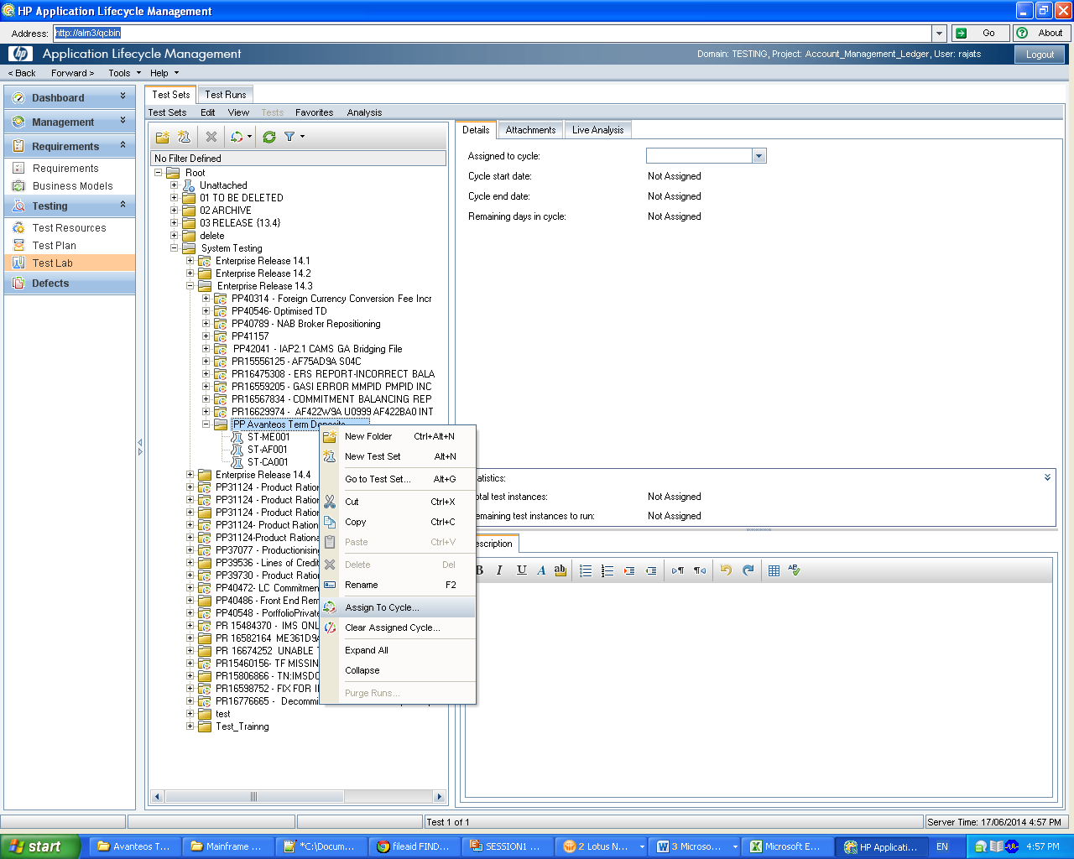

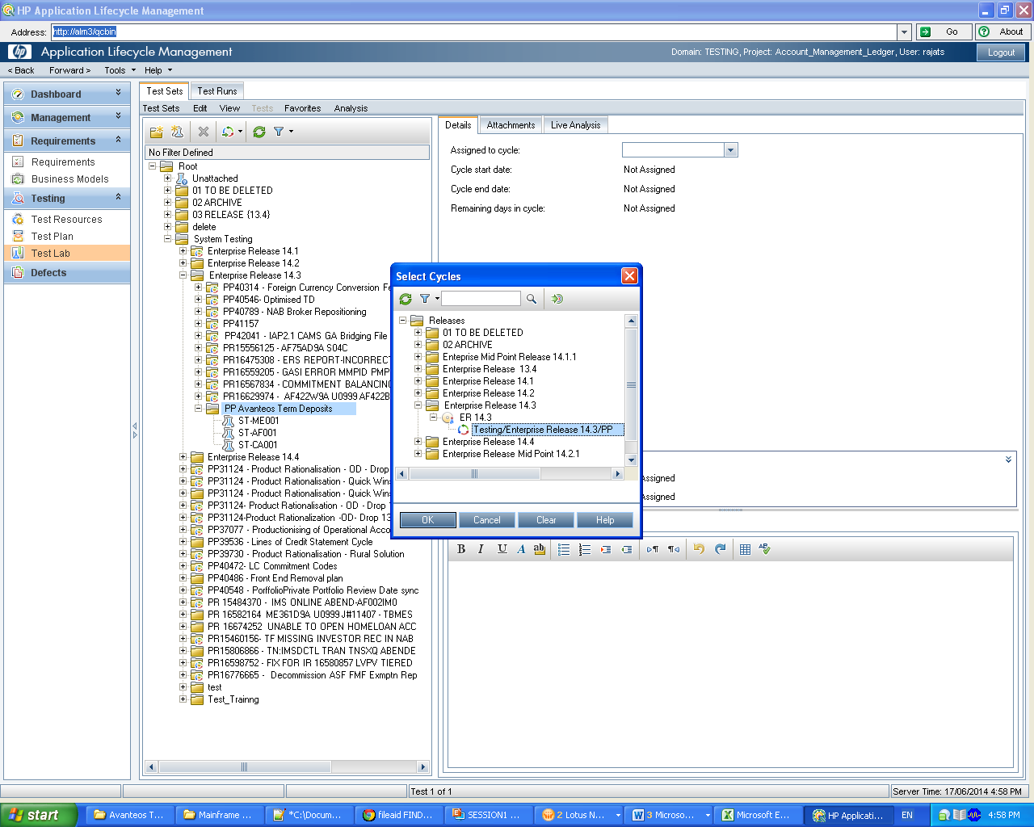

Give Planned execution date as todays date

